BOEI Web Interface

Web features:
- Setup Wizard
- Status Summary screen
- Preferences screen
- Scoring section
- Group & Individual reports

- Setup Wizard:
- Accessed from the “Establish Assessment Group Settings” window after clicking “Add Group”
- Either from a BOEI tab shown only to BOEI users, or as an option after the “receive email notifications” radio button [TBD with Rick]. Preferred button text is “Set Preferences”
- Wizard consists of 7 tabbed screens as follows:

Tab #1
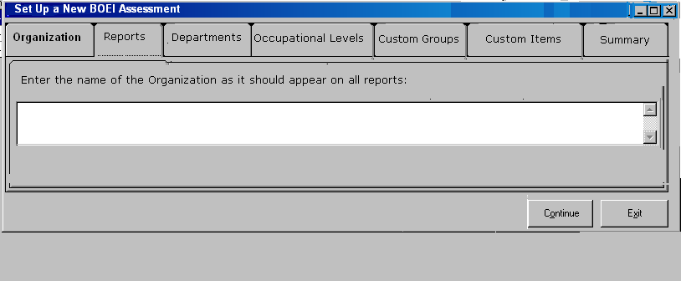

Tab #2
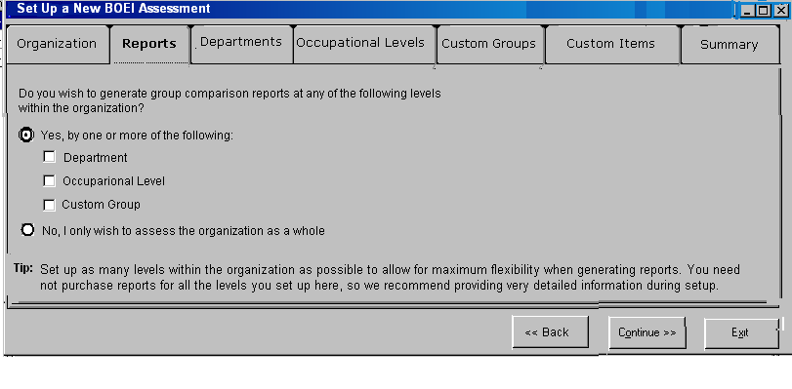
Gray out the “Yes” options if “No” radio button is selected.
Tab #3
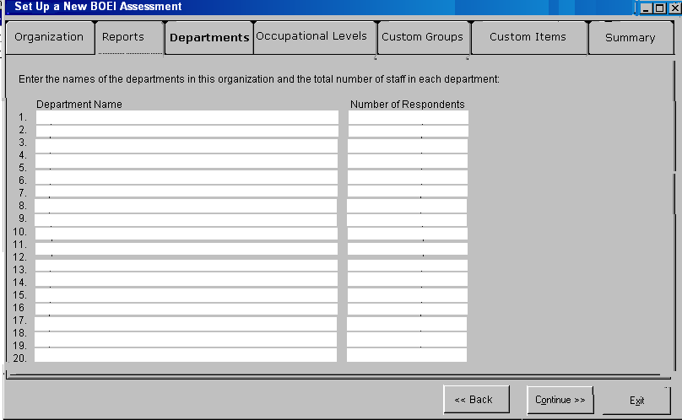
Up to 20 possible Departments

Tab #4
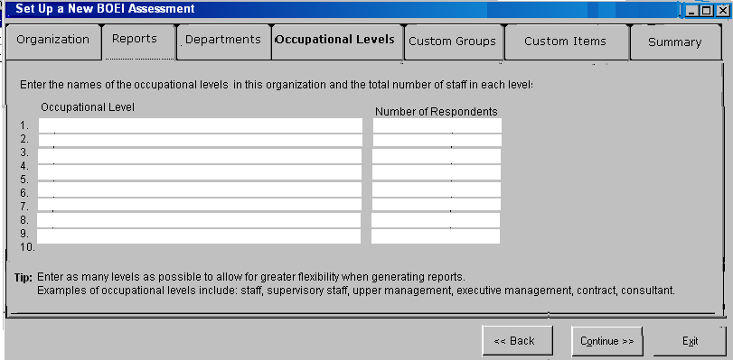
Up to 10 possible Occupational Levels

Tab #5
Custom Groups screen is the same as Occupational Levels screen, except for two changes:
- Replace “occupational level” text in instructions and table header with “custom group” (case sensitive)
- Replace Tip text with the following:
Select a single area of interest so that each person in the organization belongs to only one custom group. Examples of areas of interest include: project teams, length or service in years, countries in which the organization has staff, type of contract, and salary level.
If the custom group type is “length of service,” the groups entered above might be: Less than a year, 1-2 years, 3-5 years, 6-10 years, More then 10 years.

Tab #6
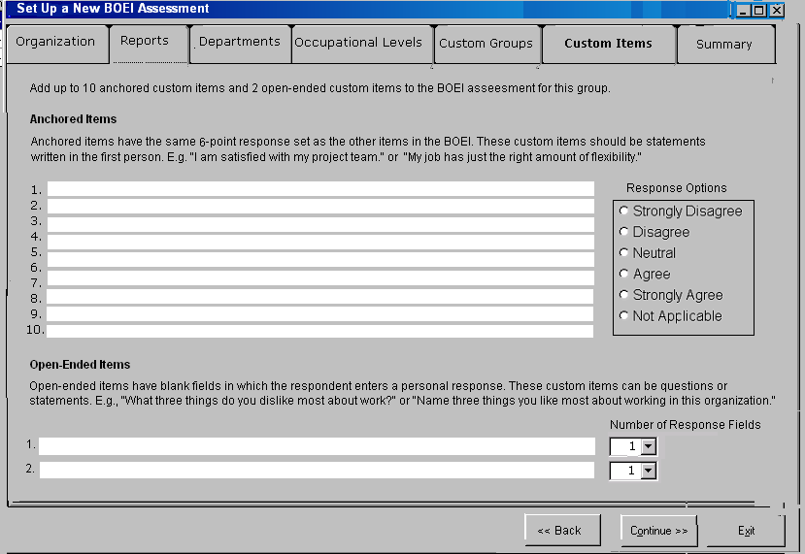
Open-ended questions have 1 response field.

Tab #7
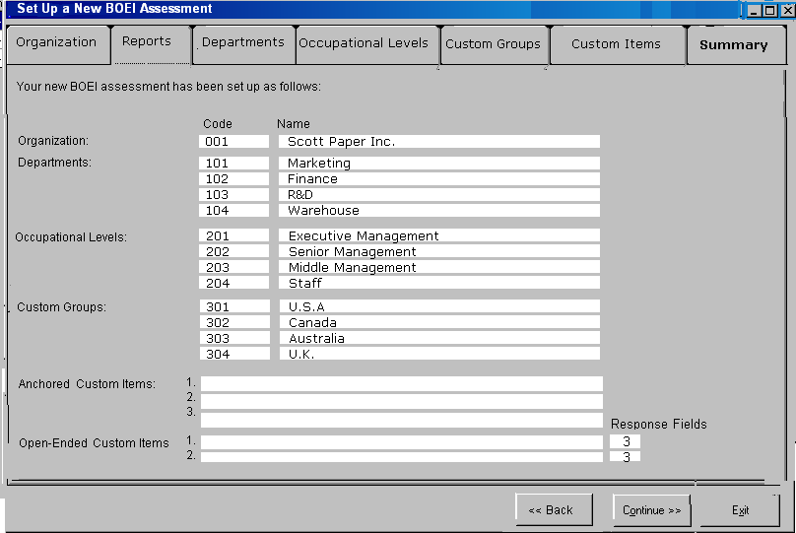
As shown above except that the fields should not have white backgrounds. Better to show as a table with gray background and black rules. Must use “Back” button to add/modify entries.
2. Status Summary:
- dynamic (must reflect current respondent info to be helpful)
- # and % of completed respondents in each group
- % is based on # of total respondents provided in Setup
- left column is based on the departments and/or groups provided in Setup

Department | # of Complete Assessments | # of Projected Assessments | % Complete
Marketing
Finance
R&D

Occupational Level | # of Complete Assessments | # of Projected Assessments | % Complete
Staff
Supervisors
Executive

When you are satisfied that you have enough completed BOEI assessments, click Score.

CLOSE SCORE
3. Preferences:
- This screen will be accessed via Groups > Setup > Edit Group Settings > Set Preferences
- Info is the same as Tab #7* in the Setup Wizard, as shown below except that the fields should not have white backgrounds. Better to show as a table with gray background and black rules.
- Clicking “Edit” launches the Setup Wizard*; show the completed fields in the Wizard, but gray out any fields that cannot be changed according to these rules:
- If 0 assessments complete, administrator can add/modify these fields
- After 1 assessment complete, administrator can add depts, levels, groups, but not custom items.
- Admin cannot change or remove any entries after the first assessment is received.

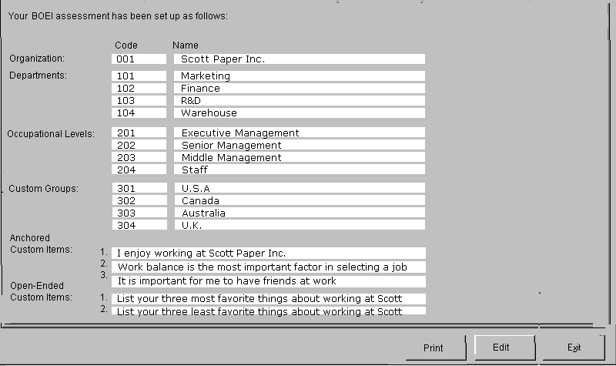
*Clicking “Set Preferences” from the Setup page could direct the user to the last page of the Wizard to avoid having two nearly identical setup pages.

4. Scoring Section:
- admin will see all individual records
- new/unscored records will show at top of records list
- Score All button available to BOEI users only (no need to select individuals for scoring)
- respondents can still access the BOEI after scoring
- option to rescore: if a new person completes the BOEI, must rescore all (charge another use)
Steps:
- Score: Score All
- Confirmation screen: lists all respondents by unique ID; # of uses being used; printable receipt; phone MHS for more uses.
- Generate Organizational Report: must be done first as this is the reference group for other reports.
- (Optional) Group Reports
- (Optional) Individual Reports

5. Group & Individual Reports
- Access from “Group Reports” as with EQ-i.
- These reports will not include unscored assessments/“stragglers”
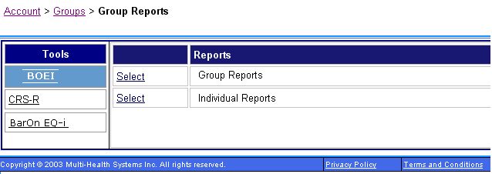

Group Reports
- Do you wish to compare
- Departments
- Occupational Levels
- Custom Groups

- Do you wish to include the organization as a reference group?
Yes No

- What departments* do you wish to include in the group report (max. of 5)?
List of depts*
from Setup
*Replace with occupational levels or custom groups based on choice in step #1.
Org name (if Yes in #2)
+ up to five depts* per report
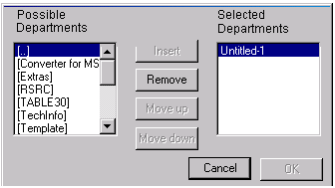
- Confirm
- List # of respondents per department
- Mention that a use will be used

Individual Reports

- Do you wish to generate individual reports for all the respondents?
Yes No

- (If yes, continue to #4. If no:)

Generate individual reports for
- A department
- An occupational level
- A custom group
Back << Continue >>

- Select the group for which you wish to generate individual reports:
(Show a radio button list of the names of the departments, levels, or groups as selected in step #2, e.g.,:)
- Staff
- Supervisors
- Executive
Back << Continue >>

- Select a reference group.

Compare each individual’s scores against the entire organization and his or her
- Department
- Occupational level
- Custom group
- No other reference group

Back << Continue >>

- [Can we have a screen here showing the individual report specs selected? E.g.:]
Individual reports for all supervisors will be generated free of charge. Individual results will be compared against the respondent’s organization.

Back << Finish >>

Notes on individual reports:
- do not deduct a use
- limitless regeneration once scored
- report compares all in group to Org, Dept, or Level
- omit groups with fewer than 3 complete assessments: show these groups in a warning
“A group you selected has fewer than five respondents. This group will not be included in the report to respect the privacy of the individuals involved. If more respondents complete the BOEI, you can rescore the entire group and generate new individual reports.”
- Org is a forced reference group

Notes on reports in general:
- Reports will disappear after 5 days
- Can rerun the identical report at no extra cost?
- Yes at Org level if no new respondents
- No for groups
- Yes for individual

